CMSC 204
Huffman Lab

- Create a Huffman Tree and generate the codes for each character of the following input:
create a huffman tree
For consistency:
- If same frequency – put in priority queue alphabetically; put space before other characters of the same frequency
- Add subtrees to end of group with same priority
- Lower number has higher priority (goes to front)

Codes for each letter
(the ‘blank=100’ says that the code for a space is 100)
[ =100, a=110, c=10110, e=01, f=001, h=10111, m=0000, n=0001, r=1110, t=1111, u=1010]

Now encode “create a huffman tree”
1011011100111011110110011010010111101000100100001100001100111111100101
Seperated by space for ease
10110 1110 01 110 1111 01 100 110 100 10111 1010 001 001 0000 110 0001 100 1111 1110 01 01

- Based on the following Huffman tree and binary sequence, what is the text

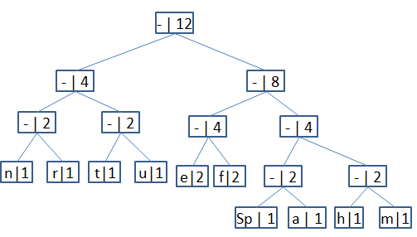

Answer:
1110011101101111111010001100010001100100
h u f f m a n _ t r e e
huffman tree
(the underscore is a space)

